**logistic regression** does **not** use **Mean Squared Error (MSE)** as its loss function.

### ✅ ****Why not MSE in Logistic Regression?****

* **Logistic Regression** is a **classification** algorithm (typically binary or multiclass), not a regression one.
* MSE is suited for **regression tasks** and assumes linearity and Gaussian errors.
* When used in classification, **MSE can lead to non-convex cost functions**, making optimization harder.

### 📉 ****Instead, we use: Logistic (Log) Loss****

The **log loss** (also called **binary cross-entropy**) is the appropriate loss function for logistic regression.

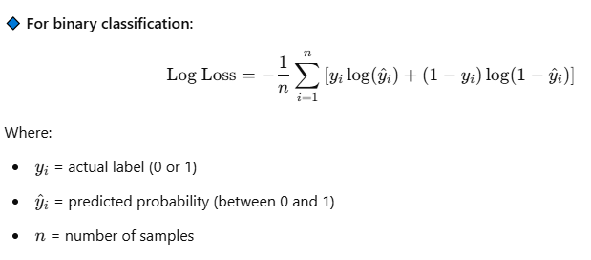

### 🎯 ****Convexity and Minima****

* **Log loss function is convex**, meaning:
  + It has **a single global minimum**
  + **No local minima**, unlike MSE when used improperly in classification
  + Gradient descent or similar optimizers can efficiently find this global minimum
* Uses “lbfgs” variant of gradient descent for optimization
* Logistic regression by default applies L2 regularization to avoid overfitting